**CENWP-ODJ7/12/2023**

**MEMORANDUM FOR THE RECORD**

**SUBJECT: *23JDA27 Steelhead Mort in NFL***

On Tuesday 11 July 2023, at approximately 1500, JDA fisheries personnel noticed several shad morts and a Steelhead mort on the upstream picketed leads in the North Fish Ladder. The shad were cleared off the picketed leads and the steelhead was removed with a net. It was scanned for a PIT tag (no tag) and returned to the river.

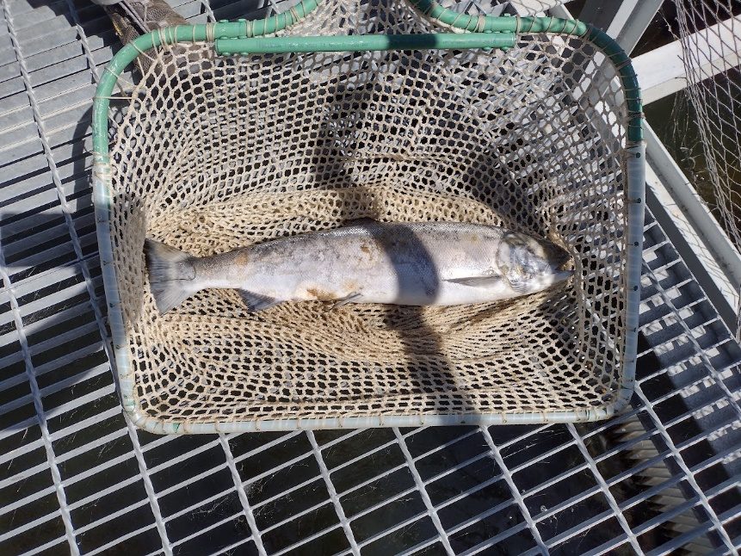

1. Species – Steelhead
2. Origin – Unclipped
3. Length – 26”
4. Marks and tags – N/A
5. Marks and Injuries found on carcass – Some descaling, fungus
6. Cause and Time of Death – Unknown
7. Future and Preventative Measures – N/A

Sincerely, Project Fisheries